Declaration of Biological Shipments for RESEARCH
Please use this form to ensure timely veterinary clearance of biological specimens to Germany.

AWB No
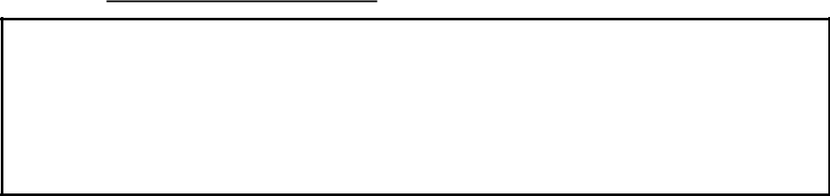

Selection 1: any biological specimen of ANIMAL origin

You need an invoice stating:

- The correct name and origin (source) of the reagents

- The number of vials / or other items

- the packaging must be labeled”

Selection 2: highly purified antibodies.

Fill in the correct name (i.e., goat anti mouse XYZ )

□ monoclonal □ polyclonal

state: the antibody was separated from plasma/serum or ascites fluid and highly purified so that animal disease or other pathogenic agents were killed off or effectively removed.

if not see Selection 4 and 5

Selection 3: Cell cultures, Cell lines,

Fill in the correct name:

in : □ serum free medium □ commercial medium with serum (see Selection 4 and 5)

Selection 4: □ Blood / Serum, □ Tissue, □ Organs □. Other.

Fill in the correct name of the animal concerned:

a.) fixated: in:

 |  | □ Alcohol |  | % □ Formalin | %□ Paraformaldehyd: | %
b.) untreated: |  | the consignee will have had to apply for a special derogation
state:
state: | The materials sent
- are non- infectious research material,

- do not contain any pathogenic agents

- were never contaminated by any infectious material..

Selection 5: The material will be sent in ready-made, commercial serum

□ yes: Cat. No. produced by

Product Data-Sheet has to be attached

- no: the consignee will have had to apply for a special derogation

Selection 6: otherwise not named biological specimens: □ pathogenic □ apathogenic

Please provide scientific name:

Intended Use:
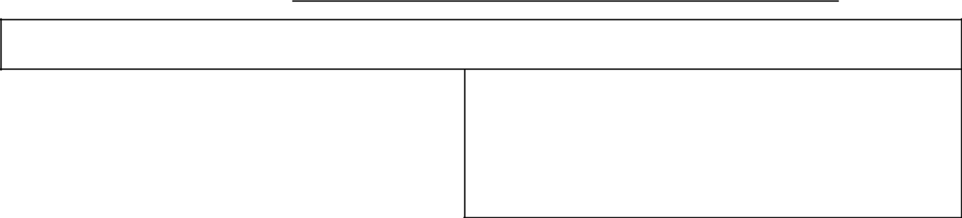

If you do not have a stamp, put your statements on a separate letterhead

Please attach this form on outer packaging.
For further questions or assistance
regarding information of needed documentation
of biological shipments to Germany please email:

DE_GTS_SPECIALHOLD@fedex.com

This information is correct and true.

date / stamp / sign

In-Vitro laboratory reagents COMMERCIAL use

Please supply the necessary documentation to ensure timely veterinary clearance of animal derived laboratory reagents to Germany.

Selection 1: | any Biological Product of ANIMAL origin. |  |  |  |  |  |  |  |  |  |  |  | You need
an invoice stating: |  |  |  | Consignee and Consignor
• | The correct name and origin (source) of the reagents given in the invoice
• | The number of receptacles / net weight in milligram are required for all products
• | physical products must be labeled
• | and marked for their purposes i.e.:“ for in-vitro research”
For In-vitro Diagnostics / Medical Devices (CE approved): |  |  |  |  |  |  |  |  |  |  |  |  | You need:
a statement:
 | all the items contained in the shipment :
 | AirwayBillNumber: ……………………………………………..
 | meet the criteria of in-vitro diagnostics /medical devices
 | following Directive |  | 98/79/EC or Directive 93/42/EWG
 | manufacturer: |  |  |  |  |  | i.e Cell Marque
 | authorized representative: |  |  |  |  |  | i.e. Emergo group
For intermediate products, products intended for further manufacturing:You need:
 | The proper Declaration following the Regulation EC No. 142/2011
 | • | This certificate will be issued by the consignee.
 | • | Please make sure you are listed as
 | • |  |  |  |  |  |  |  |  | approved for the import into the EC.
 | • Please make sure |  |  | the consignee |  |  |  | is listed as approved
For untreated blood products :(i.e. Serum, BSA) |  |  |  |  |  |  |  |  |  |  |  |  | You need:
 | The proper health certificate following the Regulation EC No. 142/2011
For treated blood products :(i.e. Serum, BSA) |  |  |  |  |  |  |  |  |  |  |  |  | You need:
 | The proper health certificate following the Regulation EC No. 142/2011
For ready made laboratory reagents: |  |  |  |  |  |  |  |  |  |  |  |  | You need:
 | Provided they are none of the above, an invoice (see selection 1)
 | But they have to be ready made for the EU common market,
 | including the proper labelling





